MIT-AITI Kenya 2005 Final Project:
数独

Sudoku is a Japanese puzzle game that has recently become quite popular in England. The puzzle board is a 9x9 grid. There is only one rule to solving the puzzle:

Fill in the grid so that every row, every column, and every 3 x 3 region contains the digits 1 through 9.
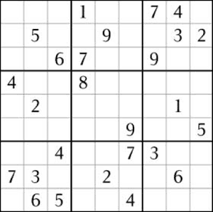
Puzzles start out with a number of cells called givens that are already filled in and cannot be changed. Here is a sample Sudoku puzzle:

A filled-in row must have one of each digit. That means that each digit appears only once in the row. For example, the above puzzle’s top row could be filled in as:
3
1
8
4
5
6
2
7
9
3 | 9 | 2 | 1 | 5 | 8 | 7 | 4 | 6

Similarly, each digit must appear in a filled-in column exactly once. The first column could be filled as is shown to the left:

There are nine 3x3 boxes, or regions surrounded by thick lines that must contain each digit exactly once. The top-left region could be filled as:
3 | 9 | 2
1 | 5 | 7
8 | 4 | 6

Note that these example values may not be consistent with the actual solution. Try to solve it for yourself. Designing good puzzles is an art. Properly formed puzzles have exactly one solution and often the givens are presented in a symmetrical pattern. Badly designed puzzles could have many solutions or none at all.
Your Assignment:

For this final project, you will take the provided source code and implement the missing functionality. The missing functionality will be noted by “/* TODO: … */” comments in the code. You should try to implement as much of this functionality as possible. Each piece of missing code can be implemented independently of the others, so you may proceed in any order.

For more information on Sudoku:
http://www.sudoku.com/
http://en.wikipedia.org/wiki/Sudoku/
http://www.sudoku.org.uk/

Happy hacking!

